Creating Accessible Documents

Quick Start Guide for Sacramento County Employees (Draft 02.02.22)
The Americans with Disabilities Act (ADA), the California Fair Employment Act (FEHA) and other Federal and State civil rights laws require government entities such as Sacramento County to have effective communication with individuals with disabilities. This includes creating and publishing documents that are accessible to people who are blind, visually impaired, or who have sensory processing or cognitive disabilities.
When creating a new document, follow these basic steps to ensure the information it contains is accessible to and usable by people with disabilities.

Start with Microsoft Word
Microsoft Word is commonly used among people with a variety of disabilities because it is reasonably accessible. Word documents can be read by assistive technologies such as screen readers and Braille devices. Properly formatted Word documents can easily be converted to accessible PDF documents.
- Use a 12 point Sans Serif font. Verdana is the recommended font used for Sacramento County documents. Arial is a common preference in the disability community.
- Use the Paragraph Spacing function, not a space or hard return to separate paragraphs or lists.
- Use simple language and short sentences.
- Provide a table of contents for long documents.
- If using color, ensure sufficient contrast for visibility for people with low vision.

Create Headings
Headings and sub-headings help people who are visually impaired to understand how the document is organized. Screen reader and Braille users can also jump between headings, which makes navigation much more efficient. Using the font options to make text larger and bold does not make it a heading.
How to create Headings: Under Styles in the Home tab, you can use the built-in Heading styles like “Heading 1” and “Heading 2”. If there are additional levels of headings within the document’s outline, use “Heading 3”, “Heading 4”, etc. You can format your own Headings by clicking on the icon on the bottom right of the Styles menu, then select the “Manage Styles” icon at the bottom right of the dialog window.
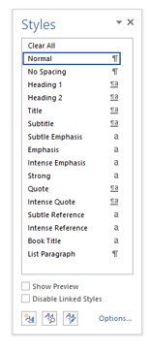
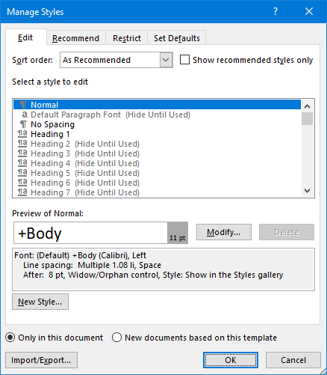

Use Lists
Create lists using Word’s built-in tools for ordered (numbered) and unordered (bulleted) lists. This makes the content easier for screen reader users to fully understand. Numbering is helpful for many people who are blind or visually impaired as a way of organizing information.
How to create Lists: Under Paragraph in the Home tab, select either the Bullets, Numbering or Outline option to create a list within the document.

Create Meaningful Hyperlinks
When including links to web pages or other documents, format the link using language that conveys relevant information about the destination of the link. Link text should be unique within a page, should be meaningful when read out of context, and should help users to know something about their destination if they click on it. Link text such as “Click here” and “More” don’t meet these criteria. Screen reader users can generate a list of links and navigate them alphabetically. Users of speech recognition technology can select a link with a voice command like “click” followed by the link text, so it is helpful to use unique link text that is short and easy to say.
How to create a meaningful Hyperlink: Word automatically creates a hyperlink when a user pastes a full URL into a document. Highlight the hyperlink, then right click and select Hyperlink or hit Ctrl + k. Insert the URL in the Address field and select OK. Change the text in the Text to Display field to a more meaningful description.
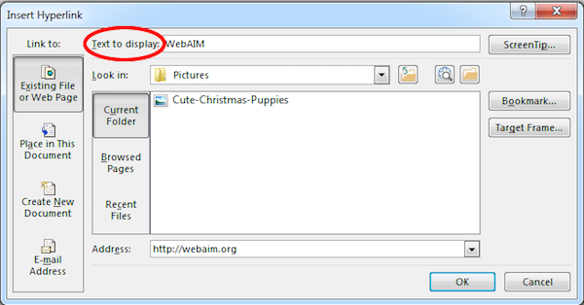
Learn More: Visit Microsoft website for more information about creating accessible Hyperlinks.

Add Alternate Text for Images
Alt text is a description of photos, illustrations or other graphic images that cannot be read by screen reading software or may not be usable by people who are visually impaired. Include alt text for all images that are informative to the content. It should be brief, but long enough for a person who is blind or visually impaired to get the same information as a sighted person would get from glancing at the image. If there is text in the image, it should be included in the alt text unless it appears nearby in the body of the document.
How to add Alt Text: Right click the image and select Format Picture. Within the Format Picture dialog, select Alt Text and enter information in the Description field.
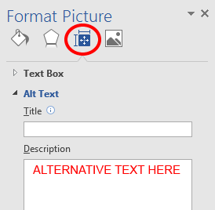
Learn More: Visit Microsoft website for more information about creating effective Alt Text.

Create Tables with Clear Structure
Tables need simple structure with column headers to be accessible, and help guide a screen reader user. For basic tables, identify which row contains the column headers. More complex tables, such as those with nested rows or columns, can only be made accessible within HTML or Adobe PDF. Often complex tables can be simplified by breaking them into multiple simple tables with a heading above each. Summarize the data contained in the table in the text of the document so that people using screen readers can still receive the information even if the table is not compatible with their screen reader.
How to Set Table Structure: Select the Insert tab on the Ribbon, select Table and then choose Insert Table from the drop down menu. Select the number of rows and columns for the table and click OK. A new tab, Table Tools, will appear on the ribbon. To add table headers, select the desired row(s) in the table, then from the Table Tools tab on the ribbon, select Layout, then choose the Repeat Header Rows option.
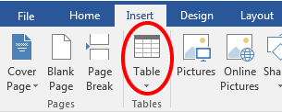
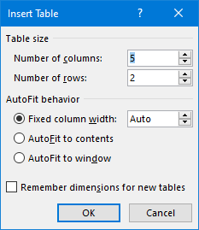
Learn More: Visit Microsoft website for more information about creating Accessible Tables.

Use the Accessibility Checker
When you have completed the steps above, use the built-in Microsoft Accessibility Checker to test the overall accessibility of the document. The checker provides Inspection Results, feedback about the importance of each item, and tips on how to repair issues. If you are updating a document created by someone else, run the Accessibility Checker to see if there are any issues that need to be addressed.
How to Check for Accessibility: Select the File tab on the ribbon. On the Info bar, click Check for Issues and select Check Accessibility from the drop down menu.
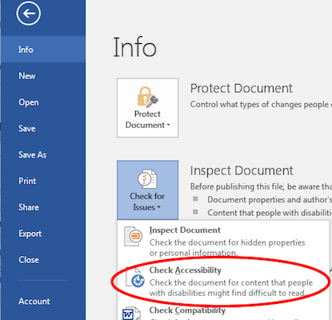

Exporting from Word to PDF
When exporting to PDF, take specific steps to preserve the accessibility features of the Word document, including heading structure, alternate text for images, and markup that explicitly identifies lists, tables, document language, and other content that is important for accessibility. Do not print or scan to PDF. This method of creating a PDF does not preserve the document’s accessibility features.
How to Export to PDF: Select the File tab on the ribbon, then click “Save As…” and select PDF. By default this preserves the document’s accessibility features. When saving, select Options and be sure that “Document structure tags for accessibility” is checked. This is checked by default, but could become unchecked under certain circumstances. If you select “Minimize Size” to reduce the size of your PDF, be sure to repeat the preceding step, as this option might uncheck the “Document structure tags for accessibility” checkbox.
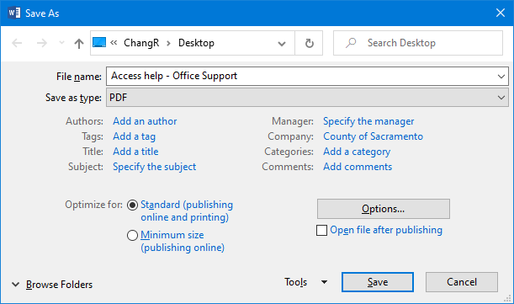
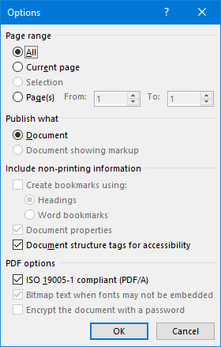
Learn More: Visit Microsoft website for more information on creating accessible PDFs.

Draft February 2, 2022 CB

